Customer Name ______________________________________________________
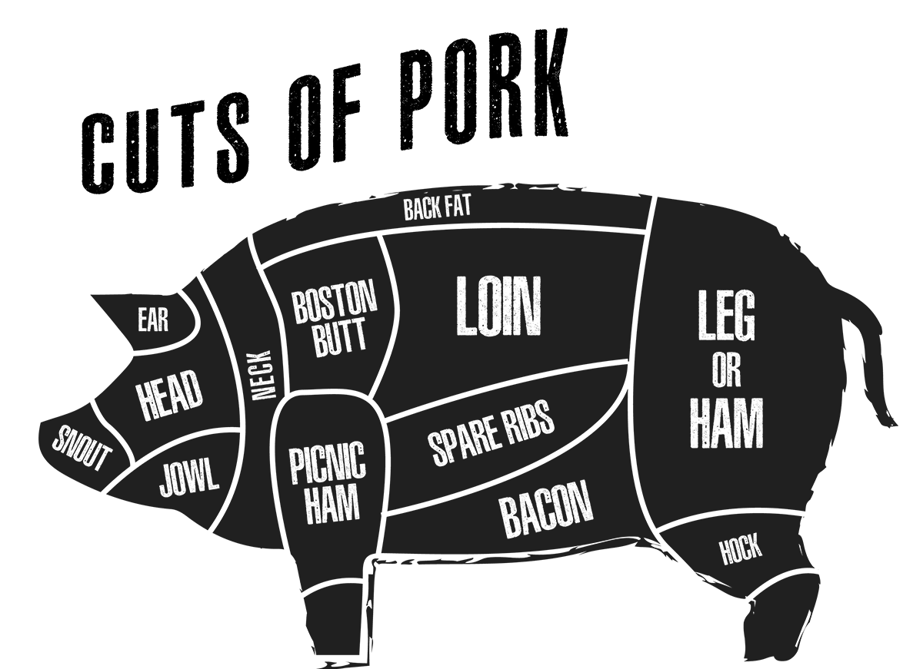

We want to make sure that your pastured pork from Red Ledge Farm is cut to your exact preferences. Most of the pork will be packaged into approximately one-pound packages unless you specify otherwise. Fill the cut sheet out the best you can and if you have any questions please call Josh at 860-319-7050.

Pork Loin (About 10-15 lbs. per half) – Most people prefer to have the loin cut into 1 ¼ inch bone in chops. If so, they will be packaged two per package. If you would like anything other than that let us know.
____ - All Chops - Cut at _____ inches thick
Or
____ - Other (Specify) ______________

Belly (About 8-12 lbs. per half) – Most people want the belly made into bacon. We cure/smoke the bacon on site at an addition cost of $3 per pound. The other option is to keep the belly fresh. Fresh belly has a high fat content and can be used to make burnt ends or oven roasted.
___ - Bacon - $3 per pound additional cost
___ - Fresh Belly left Whole
___ - Fresh Belly Cut into ____ lb. pieces.

Ham (About 15-25 lbs. per half) – For most commercial pigs, the ham is cured/smoked into the traditional ham. With pastured pigs, most customers decide to keep the ham fresh. Fresh ham can be ground for sausage, cut into pork steaks, boneless pork roasts or stew meat. You can choose a combination of those products. At this time if you would like your ham cured/smoked it will have to be brought to another facility. We can recommend some places that we have used in the past.
Ham – Continued
___ - I would like it kept whole for curing
___ - I would like to have it cured but cut into (specify) _____________________
___ - Ground Pork _____ lbs.
___ - Ground for Sausage ____ lbs.
___ - Pork Steaks ____ lbs.
___ - Pork Roasts _____ lbs. each
___ - Pork Stew Meat _____ lbs.

Spareribs – Most people want the most belly/bacon they can get. If so, the spareribs won’t be very meaty. You can still keep it as a rack of ribs or we can bone it out for ground pork or sausage.
_____ - Rack of Ribs
_____ - Boned Out

Back Fat and Leaf Lard (About 7-15 lbs. per half depending on cross or pure Mangalitsa) – 150 years ago we used pork fat for lard. Lard was used for cooking, making candles or curing for lardo. This was replaced by margarine, Crisco and vegetable oil. Studies show that animal fat, especially pork fat, is much healthier than the current options. Studies of Mangalitsa fat show that their fat is even more healthy than regular pork fat. Our family uses lard almost exclusively. We also use ground fat to mix with wild game. If you are interested in having us make candles, give me a call to discuss it further.
___ - Left into ___ lb. chunks (you may choose this if you are going to have another facility use it to grind with wild game)
___ - Ground and into ___ lb. packages (possibly to render yourself, we can give you instructions on how to render it at home using a crockpot)
___ - I would like to have Red Ledge Farm render the fat to use for lard. We charge $2 per half pint jar. It takes around ¾ of a pound of fat to make a half pint jar of lard.

Jowl (About 1-3 lbs. per half) – If you like bacon, you will love cured/smoked pork jowl. It can also be kept whole and cooked like fresh belly or ground.
____ - Cured/Smoked - $3 per pound additional cost
____ - Fresh Whole
____ - Ground

Boston Butt (About 8-12 lbs. per half) – Boston Butt is commonly kept as a roast and used to smoke for pulled pork. It has great intermuscular fat. It makes great ground pork or can be ground for sausage.
____ - Boneless Roast
____ - Bone-In Roast
____ - Ground

Picnic Ham (About 5-10 lbs. per half) – The picnic ham can be kept whole as a roast or cured/smoked. Most people have it ground.
___ - Bone-In Roast
___ - Ground

Pork Shank (About 2 lbs. per half)
____ - Whole
____ - Ground

Offal (About 5 lbs. per half)– Would you like the heart, liver, kidneys or caul fat?
___ - Yes
___ - No

Ground/Trimmings – What percentages would you like? We make sausage on site. The price is $1.50 per pound for bulk sausage and for sausage links, add $1.50 for a total of $3 per pound. If you have a place that you patronize to make sausage, we can pack the ground pork into five-pound packages to bring to them at no extra cost. (keep in mind our sausage recipes are a five-pound minimum)
____ % Regular Ground Pork
www.redledgefarm.com
____ % Sweet Italian Bulk Sausage
____ % Sweet Italian Linked Sausage
____ % Hot Italian Bulk Sausage
____ % Hot Italian Linked Sausage
____ % Bulk Breakfast Sausage
____ % Linked Breakfast Sausage

